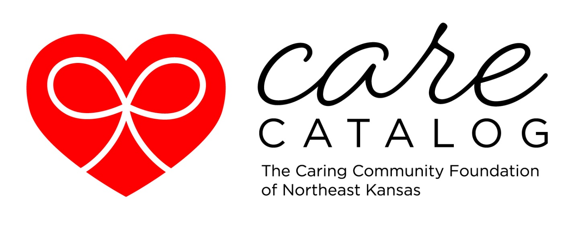
2025 Caring Community Foundation Care Catalog Project Proposal
Complete this form and e-mail it back to us at vramage@ccfks.org. We will accept Care Catalog requests through September 25th; this is the last day project requests will be accepted. We will notify you as to whether or not your project request is accepted for the Care Catalog.
Highlighted information below will not be posted.
Contact Person’s Name__________________________________________________________
Email_________________________________________________________________________
Phone number__________________________________________________________________
Nonprofit Organization mailing address______________________________________________

Name of Nonprofit Organization____________________________________________________
Website address and/or Facebook page______________________________________________
______________________________________________________________________________
If you are not a 501(c)(3), public or private accredited school, or a local unit of government, you will need a sponsor that is. Who is your sponsor? Let me know if you need help finding one!
_______________________________________________

Title of your Project______________________________________________________________

Provide a compelling paragraph describing your project and how you will use the funds. Tell the donor how you plan to apply their gift and the impact it will have. What is the need? Are others helping? Be specific! Be inspiring!

Amount Requested _____________________________________________
Please don’t ask for an amount larger than you realistically expect to get. People want to know that their donations will accomplish something; they don’t want to wonder what happens to their donation if you don’t reach your goal. $10,000 is the maximum but in most cases, less will be more attainable and more palatable for donors. Some projects can use any amount of donation, if that is true for yours, say that in your project description. Let me know if you have questions!
If we notify you that your project has been accepted, you will be required to do a small checklist of marketing and outreach activities:
- Encourage your members, board, and/or volunteers to participate, donate, or be ambassadors for your project.

- Email and Social media post about the Care Catalog and your project. Promote special giving on incentive days.

- Send thank you notes to each donor. We will send you all donor contact information with the exception of anonymous donors.

