Caring Community Foundation Announces Grant Opportunity!
Request for Proposals (RFP)
July 1, 2026

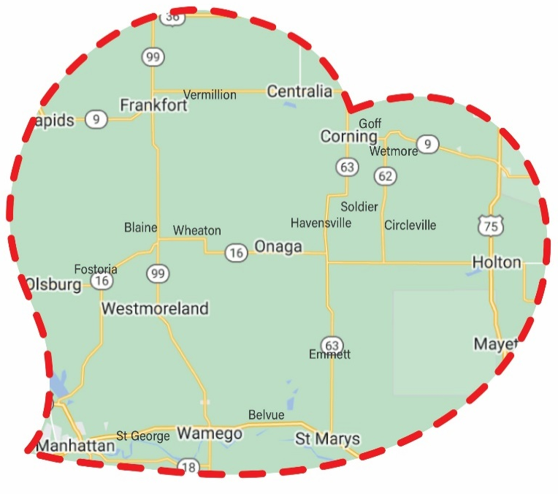
The Caring Community Foundation (CCF) exists to help enhance the vibrant communities of rural northeast Kansas. We want to develop strong relationships with our local non-profits who serve community needs with the hope that our collective efforts will revitalize our hometowns. We believe this will help make optimal communities in which to raise a family, access quality education, grow businesses, and experience art and culture.

The CCF is making $6,000 available through a competitive grant process to nonprofits based in our service area (see heart graphic). These grants will be provided by the CCF Community Fund, which is supported by our donors. We are grateful to all for making these grants possible!

Proposals are to be submitted electronically, or on paper, by Monday, August 10, 2026 to Valerie Ramage, Executive Director, Caring Community Foundation at vramage@ccfks.org or P.O. Box 54, Onaga, KS. 66521. Awards will be announced by September 11, 2026. Projects must be completed by October 31, 2027. A final narrative and budget report of the project is due to vramage@ccfks.org by December 1st, 2027. Non-compliance with these terms by an awardee, as determined by the Caring Community Foundation Board of Directors, will require the awardee to return the award to the CCF within 60 days of notification of such determination.

Who is eligible to apply: Non-profit organizations based in the Caring Community Foundation’s service area that can demonstrate their IRS-recognized tax-exempt status. If you don’t have an EIN, let us know. We may be able to identify a sponsor organization that you can apply through.

What can be funded: Charitable efforts that support community development or service, local arts, health, education, and/or local non-profit organization success.

What will not be funded: Salaries, capital requests, debt, replacement of existing funding, or projects that are political, religious, or discriminatory.

APPLICATION

- Applicant Identifying Information
Name of Organization:
Mailing Address:
Director/Contact Person:
Phone:
Email:
Geographic Area Served:
Tax exempt status and EIN:
If your group is not tax exempt and does not have an EIN, you will need to identify a Fiscal Agent Sponsor that is tax exempt and has an EIN:

- Proposal Summary
In 1-2 sentences tell us the amount of funds you are requesting and how you plan to use them.

- Program Narrative
Provide a detailed description of the program or project that you are requesting to be funded. Include a timeline showing the processes and duration of the project. Include any goals of the project, and how goals will be achieved and measured.

- Organization Description and History
In a paragraph or two, describe the history of your organization, its structure, and key staff. Include accomplishments of the organization, relevant experience and any established partnerships/relationships that will assist you in completing a successful project.

- Background of the Issue
Explain the problem or enhancement that your project will address. Include evidence of the need and evidence that your project will contribute to a solution. Why should your project be funded?

- Budget
Please complete the table below for your project. In-kind match should be noted as the value of project assistance you receive that you don’t have to pay for; this is not required, but it is helpful. Please note the source of in-kind match and funds from other sources.

Expenditure Category | CCF Fund Request | Funds from other Sources | In-kind Match | Total
Totals

- Additional Grantee Requirements:

  - Administrative Relationship: The grantee is solely responsible for administering the project, and the CCF shall have no responsibility for such. This agreement grants the Foundation no administrative control over the grantee or its operations; there is no principal/agency relationship between the Foundation and the grantee.
  - Accounting: For reporting and audit purposes, the grantee agrees to maintain records of receipts and expenditures related to the project, during the project and for a least one year following completion of the project.
  - Publicity: All planned publicity for this project shall require prior approval of, and acknowledge the support of, the Caring Community Foundation.
  - Hold Harmless/Indemnification: To the extent allowed by Kansas law, grantee agrees to indemnify and hold harmless the CCF, its board, employees and agents against all liabilities, obligations, damages, penalties, claims, costs, charges and expenses, which may be imposed upon, or asserted against, the Foundation or its representatives.

For more information or assistance please contact Valerie Ramage, Executive Director of the Caring Community Foundation, vramage@ccfks.org, 785-889-4249
Thank you for your efforts for your community!

